**Sprint 1:**

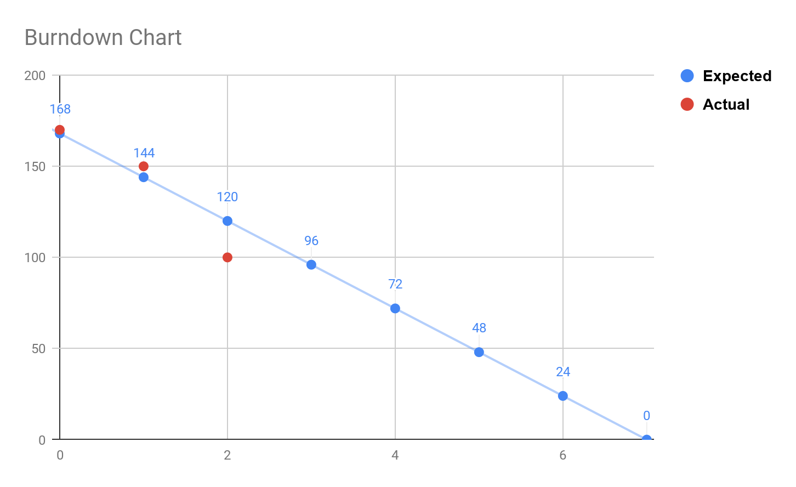

The first point represents our starting date, the second is the start of our first sprint, and the third is the end of sprint 1.

*Backlog*

* Research game theory for chess
  + - Henning, Caleb, Sausha (completed)
      * The game play really spawns from the minimax function. As long as that works, the game “just happens”. It’s not “smart” but it does a pretty decent action at the right time. We just need to figure the heuristics and representation out. (Henning)  <https://medium.freecodecamp.org/simple-chess-ai-step-by-step-1d55a9266977>
  + Building GUI interface
    - Correct board - Henning (completed)
    - Placement of colored pieces - Caleb (completed)
    - Preliminary development on move generation - Sausha (completed)

At this point in time, we have completed each of the following tasks assigned and have started getting ahead in the next sprint. We have created the board, the pieces, the movements of every piece, and have begun to work on threading, as well as, attacking situations/movements.

Future SCRUM meetings:

1. Saturday/Sunday
2. Monday
3. Wednesday

Source Code: